Airplane Seating Program
Created By:
Greg, Jacolgan, Brandon, Judy, Shenyo’a, & Mark
Coin 235 – C++ Programing
December 6, 2011
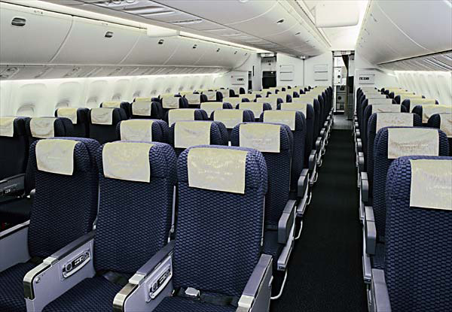

Table of Contents

- Introduction ………………………………………………………………..……3

- Screen Shots of the Program…………………………………………………4 - 7

- Walkthrough of the Program Code …………………...……………………..8 - 11

- Appendix………………………………………………………………………..12 - 19

- Airplane Seating Guide Code…………………………………………… 13 – 15

- Test Plan……………………………………………………………………16 - 18

- Improvements …………………………………………………………….. 19

- Powerpoint Slides ………………………………………………………… 20 - 23

- Introduction
The purpose of this program is for the user to select a seat(s) for a commercial airplane. The airplane has 13 rows, with six seats in each row. Rows 1 and 2 are first class, rows 3 through 7 are business class, and rows 8 through 13 are economy class. After the user has selected their choice of seat(s) a seating chart will be displayed. The seating chart will display all seats available and reserved including the choices they have selected.

- Screen Shots of the Program

The beginning part of the program prompts the user to select a seat. In Figure 1.1, the user selects ‘y’ for Yes.

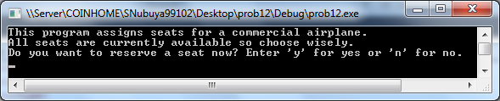
Figure 1.1
- Screen Shots of the Program (continued)

In Figure 1.2, after selecting the seating row the program prompts the user to select a row between two fixed intervals.

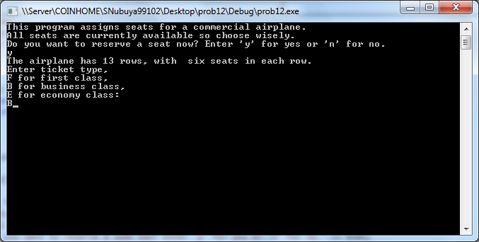
Figure 1.2

- Screen Shots of the Program (continued)

In Figure 1.3, the user is given the row number where they would like to sit, followed by the seat letter.

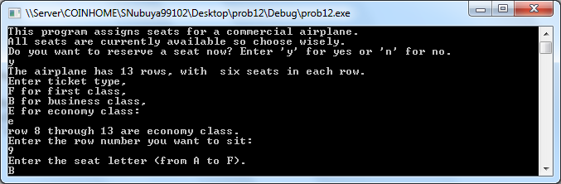
Figure 1.3
II. Screen Shots of the Program (continued)

The user than will have a choice to pick a seat number from A to F if the seating is reserved than there will be an X that will indicate it is occupied. The program will ask to repeat the cycle again choosing a different seat if the seat is available than there will be an asterisks “ * ” in its place.

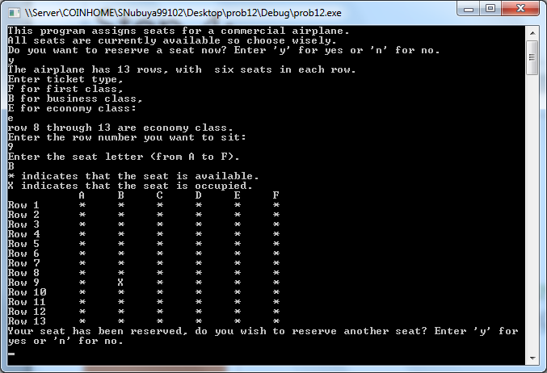
Figure 1.4

If the user answers ‘no’ the program will close automatically.

- Walkthrough of the Program Code

The first part of the code is declaring iostream, iomanip and a cctype.
The programmer added three functions to the program which were all void initialize, get Data, print Form

// Airplane Seating Program - created by Greg, Jacolgan, Sheno'a, Brandon, Mark & Judy
// December 6, 2011 - Malik page 542 #12

#include<iostream>
#include<iomanip>
#include<cctype>

using namespace std;

void initialize( char form[][6]);
void getData(char& ticketType, int& row, char& column);
void printForm(char form[][6], int row, char column);

int main()
{
Declares the ch, ticketType, and column as a character
char ch, ticketType, column;
int row;
char form[13][6];

Starts the program by asking a cout statement if user says y toupper will convert to Y than the program will start using a while loop to call the functions that were declared
initialize( form);
cout << "This program assigns seats for a commercial airplane." << endl;
cout << "All seats are currently available so choose wisely." << endl;
cout << "Do you want to reserve a seat now? Enter 'y' for yes or 'n' for no." << endl;
cin >> ch;

ch = static_cast<char>(toupper(ch));
while(ch == 'Y')
{
getData(ticketType, row, column);
printForm(form, row, column);

cout << "Your seat has been reserved, do you wish to reserve another seat? Enter 'y' for yes or 'n' for no." << endl;
cin >> ch;
ch = static_cast<char>(toupper(ch));
if(ch == 'N')
return 0;
}

return 0;
}

The first function is to see what seat the user has chosen using a for statement if the int i is 0 or less than 13 than a * will be shown. This is the same for if j is 0 or less than 6
void initialize( char form[][6])
{
for(int i=0;i < 13;i++)
for(int j=0;j<6;j++)
form[i][j]='*';
}

The getData function asks for the ticket type by using a cout statement.

void getData(char& ticketType, int& row, char& column)
{
cout << "The airplane has 13 rows, with six seats in each row." << endl;

cout << "Enter ticket type," << endl;
cout << "F for first class, " << endl;
cout << "B for business class," << endl;
cout << "E for economy class:" << endl;
cin >> ticketType;

Once the user inputs a char or letter for the seat the letter chosen as ticketType will be uppercased using the command toupper. The user will also use a while loop to show that if the ticket type is not F,B, or E than the cout statement will be an invalid ticket type.
ticketType = static_cast<char>(toupper(ticketType));
while(ticketType != 'F' && ticketType != 'B' && ticketType != 'E')
{
cout << "Invalid ticket type." << endl;
cout << "Enter ticket type," << endl;
cout << "F for first class, " << endl;
cout << "B for business class," << endl;
cout << "E for economy class:" << endl;
cin >> ticketType;

ticketType = static_cast<char>(toupper(ticketType));
}

The switch statement show the different types of classes and where each one is located by using a case
switch(ticketType)
{
case 'F':
cout << "Row 1 and 2 are first class,\n";
break;
case 'B':
cout << "row 3 throuh 7 are business class,\n";
break;
case 'E':
cout << "row 8 through 13 are economy class." << endl;
break;
}

Once you enter the row and seat number, the toupper command will convert the letter cin in the column to capital letters.
cout << "Enter the row number you want to sit: " << endl;
cin >> row;

cout << "Enter the seat number (from A to F). " << endl;
cin >> column;
column = static_cast<char>(toupper(column));

The while loop shows if the column does not equal A,B,C,D,E,or F than the code will cout “ Invalid seat choose another”
while(column != 'A' && column != 'B' && column != 'C' && column != 'D' && column != 'E' && column != 'F')
{
cout << "Invalid seat choose another." << endl;
cout << "Enter the seat number (from A to F). " << endl;
cin >> column;
column = static_cast<char>(toupper(column));
}
}

PrintForm will display the seating of the airplane by using an int i and j showing them in rows and columns
void printForm(char form[][6], int row, char column)
{
int i, j;

This will show the letter inputted in the ticketType function and display the incorrect letter as an X on the seating chart
if(form[row-1][static_cast<int>(column-65)]=='X')
{
cout << "This seat already assigned. Choose another seat: " << endl;
return;
cin >> column;
column = static_cast<char>(toupper(column));
}
form[ row-1 ] [static_cast<int>(column)-65]= 'X';

cout << "* indicates that the seat is available; " << endl;
cout << "X indicates that the seat is occupied. " << endl;
cout << setw(12) << "A" << setw(6) << "B" << setw(6) << "C"
<< setw(6) << "D" << setw(6) << "E" << setw(6) << "F" << endl;

This part of the code is used to align the columns and rows in sync
for(i = 0; i < 13; i++)
{
cout << left << setw(3) << "Row " << setw(2)<< i+1;
for(j = 0; j < 6; j++)
{
cout << right << setw(6) << form [i][j];
}
cout << endl;
}
}

Appendix
- Appendix
- Airplane Seating Code

// Airplane Seating Program - created by Greg, Jacolgan, Sheno'a, Brandon, Mark & Judy
// December 6, 2011 - Malik page 542 #12

#include<iostream>
#include<iomanip>
#include<cctype>

using namespace std;

void initialize( char form[][6]);
void getData(char& ticketType, int& row, char& column);
void printForm(char form[][6], int row, char column);

int main()
{
char ch, ticketType, column;
int row;
char form[13][6];

initialize( form);
cout << "This program assigns seats for a commercial airplane." << endl;
cout << "All seats are currently available so choose wisely." << endl;
cout << "Do you want to reserve a seat now? Enter 'y' for yes or 'n' for no." << endl;
cin >> ch;

ch = static_cast<char>(toupper(ch));
while(ch == 'Y')
{
getData(ticketType, row, column);
printForm(form, row, column);

cout << "Your seat has been reserved, do you wish to reserve another seat? Enter 'y' for yes or 'n' for no." << endl;
cin >> ch;
ch = static_cast<char>(toupper(ch));
if(ch == 'N')
return 0;
}

return 0;
}

void initialize( char form[][6])
{
for(int i=0;i < 13;i++)
for(int j=0;j<6;j++)
form[i][j]='*';
}

void getData(char& ticketType, int& row, char& column)
{

cout << "The airplane has 13 rows, with six seats in each row." << endl;

cout << "Enter ticket type," << endl;
cout << "F for first class, " << endl;
cout << "B for business class," << endl;
cout << "E for economy class:" << endl;
cin >> ticketType;

ticketType = static_cast<char>(toupper(ticketType));
while(ticketType != 'F' && ticketType != 'B' && ticketType != 'E')
{
cout << "Invalid ticket type." << endl;
cout << "Enter ticket type," << endl;
cout << "F for first class, " << endl;
cout << "B for business class," << endl;
cout << "E for economy class:" << endl;
cin >> ticketType;

ticketType = static_cast<char>(toupper(ticketType));
}
switch(ticketType)
{
case 'F':
cout << "Row 1 and 2 are first class,\n";
break;
case 'B':
cout << "row 3 throuh 7 are business class,\n";
break;
case 'E':
cout << "row 8 through 13 are economy class." << endl;
break;
}

cout << "Enter the row number you want to sit: " << endl;
cin >> row;

cout << "Enter the seat number (from A to F). " << endl;
cin >> column;
column = static_cast<char>(toupper(column));

while(column != 'A' && column != 'B' && column != 'C' && column != 'D' && column != 'E' && column != 'F')
{
cout << "Invalid seat choose another." << endl;
cout << "Enter the seat number (from A to F). " << endl;
cin >> column;
column = static_cast<char>(toupper(column));
}
}

void printForm(char form[][6], int row, char column)
{
int i, j;

if(form[row-1][static_cast<int>(column-65)]=='X')
{
cout << "This seat already assigned. Choose another seat: " << endl;
return;
cin >> column;
column = static_cast<char>(toupper(column));
}
form[ row-1 ] [static_cast<int>(column)-65]= 'X';

cout << "* indicates that the seat is available; " << endl;
cout << "X indicates that the seat is occupied. " << endl;
cout << setw(12) << "A" << setw(6) << "B" << setw(6) << "C"
<< setw(6) << "D" << setw(6) << "E" << setw(6) << "F" << endl;

for(i = 0; i < 13; i++)
{
cout << left << setw(3) << "Row " << setw(2)<< i+1;
for(j = 0; j < 6; j++)
{
cout << right << setw(6) << form [i][j];
}
cout << endl;
}
}
IV. Appendix
- Test Plan

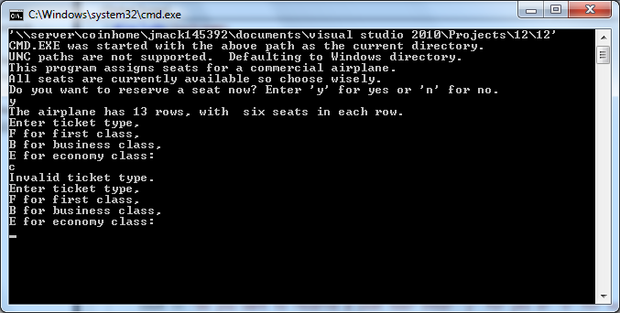

In the screen shot above, the user enters the wrong ticket type. The program will alert that you entered an invalid ticket type and ask the user again for the correct ticket type. The code only has tickets for First, Business, and Economy class types.

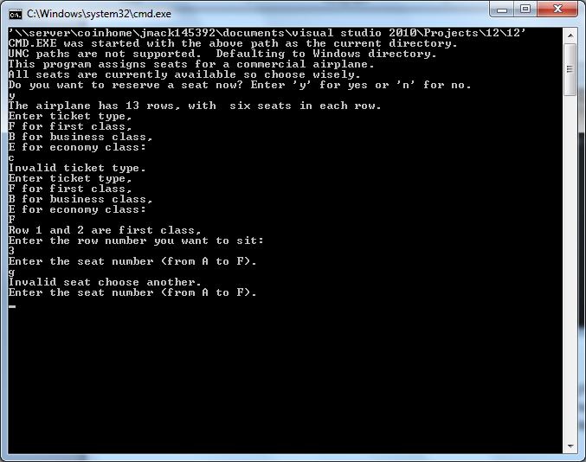

In this screen shot, the user chooses an invalid row seating number: Row 3 seat number G. An invalid message is presented to the user displaying an invalid seat choice and asks for another selection.

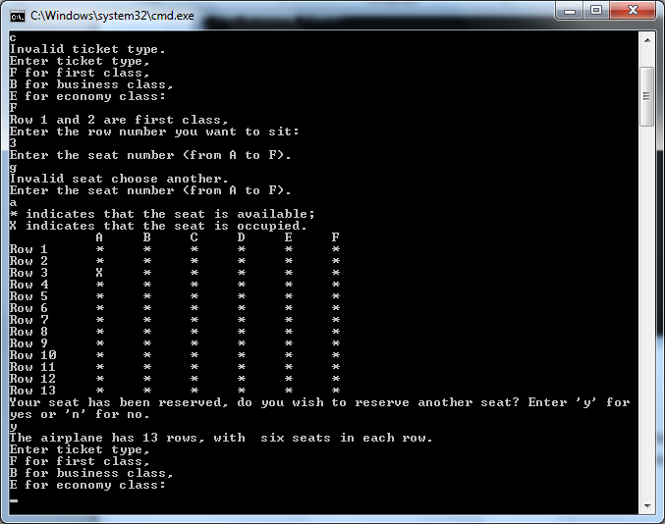

This screen shot presents the seating chart where the user’s choices are reserved. Row 3 seat A marks an “ X “ in its column is shown above.
IV. Appendix
- Improvements

- First launching the program we listed our troubleshooting variables, the correct ticket type variables were listed and we selected invalid ticket types for the program. The program reminded us that it was invalid ticket choice.
- The second test consisted of choosing the seat. The seat choices are from A to F we chose the letter G in the program, then stated that was an invalid seating choice and asked for another valid selection.
- The last test we conducted was whether the chart would show the seat selection even with the wrong seating choice at which the program did and put an “X” in the reserved seat requested.

